Navigate to your onshape account. In a new or existing project, select the “Add custom features” button
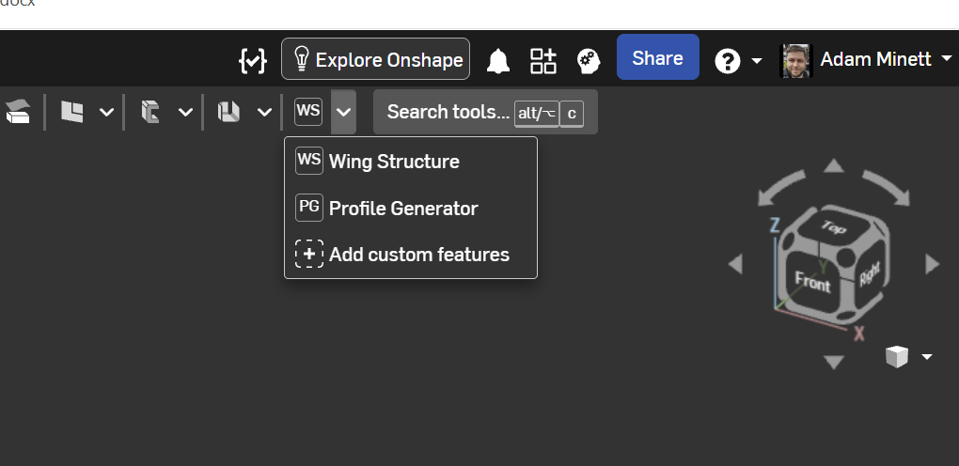

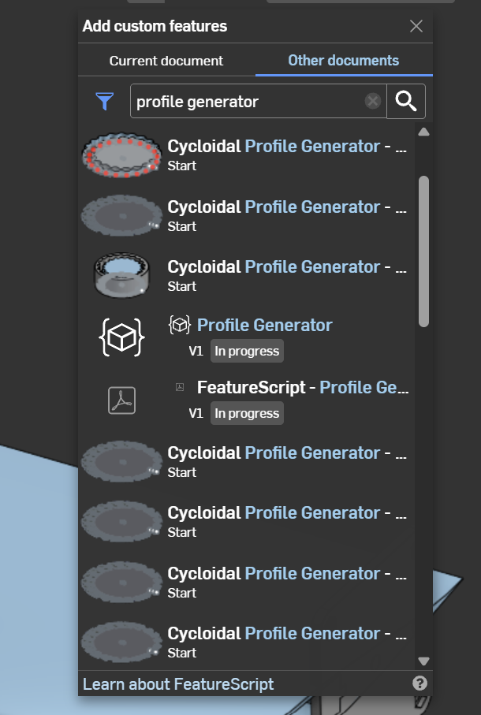
Search for “profile generator” and select the highlighted option

Select the highlighted Profile Generator option again from here.

